Workplace Mortgage Solutions Content Spec
Authored by Tony Pinto
Version 1.0 - 12/11/2004

The following is the proposed Marketing plan for Workplace Mortgage Solutions’ (WMS) Workplace Mortgage Benefit Program, as offered to LoanToolbox members.

Voice Broadcast (outbound recorded phone call):

Tim will mention LoanToolbox’s strategic partnership with WMS on at least one of the weekly voice broadcasts to our membership, including the various packages and pricing options. These calls generally drive members to our web site to find more information.

Banner ads (member’s home page and side banner):

We will create a couple of Flash banners using the WMS artwork to promote the program at launch and on an ongoing basis. The banners will link to the WMS strategic partner page. Here’s an example of what those banners look like:

Member’s Home page (limited time):

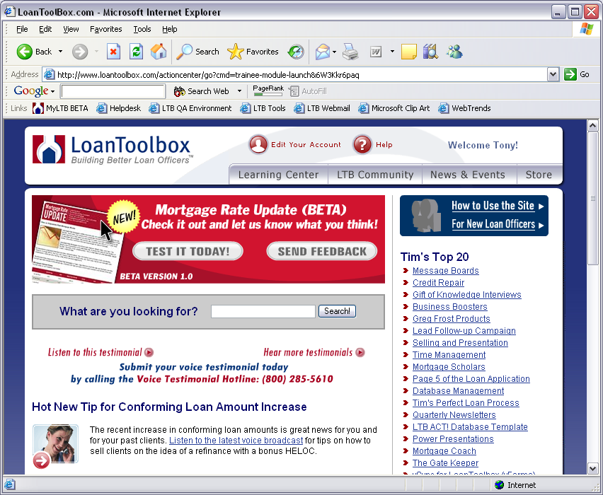
Individual content pages (ongoing):

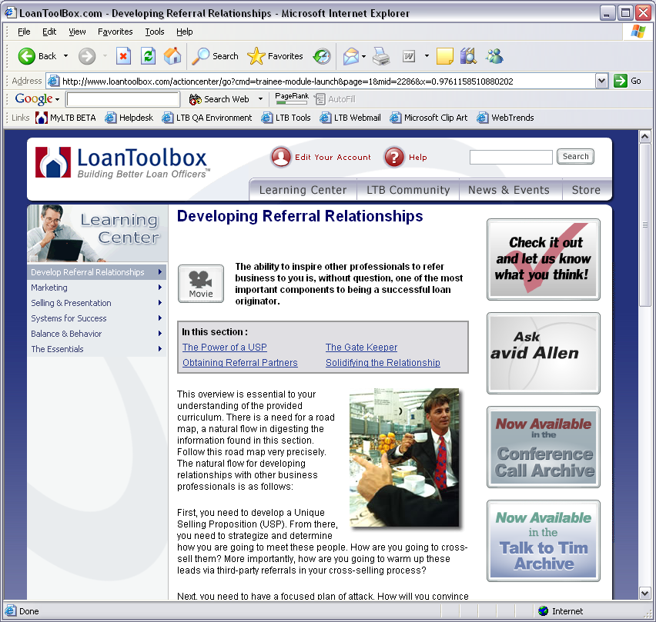

Featured Content on Member’s Home Page:

For a short time, we will also feature the announcement of the relationship on the member’s home page. This listing sometimes remains long after the Flash banner has been retired. See LTB member’s home page for details.

Email Marketing Campaign:

This will go out as part of our What’s New at LoanToolbox weekly email, and probably at least once by itself in one of our “Another Valuable Tool” emails. Here is the content:


Another Valuable Tool:
The Workplace Mortgage Benefit Program

LoanToolbox has teamed up with Workplace Mortgage Solutions (link to our WMS Strategic Partner page inside LTB) to bring you a proven strategy to increase your production volume. Discover a steady flow of new business that is less affected by market conditions - Workplace Accounts.
The Workplace Mortgage Benefit Program contains all of the key sales and marketing materials necessary to approach and build relationships with Human Resources/Employee Benefits Managers and employees.
Workplace Mortgage Solutions provides all the planning tools, step-by-step instructions, customized program & support materials, and activity tracking to help you become more successful in this untapped niche market. The program includes:
- A step-by-step workbook on targeting and approaching companies
- Print-ready designs for the marketing materials you’ll need to gain attention of Human Resources and employees
- Account tracking forms to keep your marketing efforts organized
Here’s a look at the individual components:
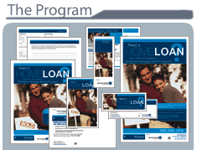
- Program Brochure
- 3 Posters
- 4 Fliers
- Tracking Forms
- Payroll Stuffers
- Letters
- E-mail Headers
- Press Release Sample
- 5 PowerPoint Presentations
- 2 Postcards
- AND MUCH MORE!
CLICK HERE to learn more about the FREE resources and special pricing offered exclusively to LoanToolbox members!

Targeting HR Directors section:

We will add similar content to the bottom of the Targeting HR Directors page on LoanToolbox, with a link to the WMS Strategic Partner page, which can be found here:

http://www.loantoolbox.com/actioncenter/go?cmd=trainee-module-launch&79w92d7REl&mid=2334&page=1

WMS Strategic Partner Page:

LoanToolbox will permanently feature WMS in the Strategic Partner section of the LTB Community section, along with other partners. This is where most of information about WMS and the program will be permanently housed. This is the proposed content:

Workplace Mortgage Solutions
LoanToolbox has teamed up with Workplace Mortgage Solutions to bring you a proven strategy to increase your production volume. Discover a steady flow of new business that is less affected by market conditions - Workplace Accounts.
The Workplace Mortgage Benefit Program contains all of the key sales and marketing materials necessary to approach and build relationships with Human Resources/Employee Benefits Managers and employees.
Workplace Mortgage Solutions provides all the planning tools, step-by-step instructions, customized program & support materials, and activity tracking to help you become more successful in this untapped niche market. The program includes:
- A step-by-step workbook on targeting and approaching companies
- Print-ready designs for the marketing materials you’ll need to gain attention of Human Resources and employees
- Account tracking forms to keep your marketing efforts organized
Here’s a look at the individual components:
- Program Brochure
- 3 Posters
- 4 Fliers
- Tracking Forms
- Payroll Stuffers
- Letters
- E-mail Headers
- Press Release Sample
- 5 PowerPoint Presentations
- 2 Postcards
- AND MUCH MORE!
The Philosophy behind the Workplace Mortgage Benefit Program
Approaching a company with a discount mortgage program is mutually beneficial. The Program provides an attractive employee benefit that:
- Enhances company's recruiting effort
- Increases employee loyalty and retention
- Increases employee productivity
- Doesn't cost the company a thing!
As a mortgage professional offering our program, you'll gain access to:
- A long-term, steady source of business
- The opportunity to create relationships with working individuals
- Explosive potential for referrals through co-workers, friends and family
- Increased production volume
Mini-Workbook
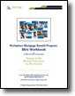
Download the FREE Workplace Mortgage Benefit Program Mini-Workbook (PDF) to learn more about the program.
Packages and Pricing
Workplace Mortgage Solutions offers three exclusive discount packages to LTB Members: Lite, Basic and Custom.
The Lite Package: FREE for LTB members! – The Lite Package is a sampling of the two complete packages offered by Workplace Mortgage Solutions. As a member of LoanToolbox, you have exclusive access to these documents, at absolutely no charge to you. These documents include:
- Human Resources Manager letter
- Human Resources PowerPoint presentation
- Home Buying PowerPoint presentation
- Paycheck Stuffer
- Seminar Flier
- Seminar Poster
CLICK HERE to read the user agreement and download the FREE content offered by Workplace Mortgage Solutions. Note: LTB members will be required to accept the user agreement before being allowed to download this free content. All members will be tracked at WMS’ request, and reported to WMS on an occasional basis.
The Basic Package: Special LTB price – ONLY $99 (normally $395!) - You will receive a CD that contains a complete How-to Workbook and all of the professionally designed PDF files and Word documents. The basic package includes marketing materials ready for you to print and use by adding your business card to each piece, or printing in the area provided on each piece. There is also room for you to print your company disclosures if required.
Here’s another look at the individual components:
- Program Brochure
- 3 Posters
- 4 Fliers
- Tracking Forms
- Payroll Stuffers
- Letters
- E-mail Headers
- Press Release Sample
- 5 PowerPoint Presentations
- 2 Postcards
- AND MUCH MORE!
Your basic package will be shipped via USPS Priority Mail to you upon receipt of the signed faxed order form and license agreement.
CLICK HERE to download a sample from the Basic Package (PDF: 4.65 MB) (link to WMS web site, target=_blank; see http://www.workplacemortgagesolutions.com/program.php) Workplace Mortgage Solutions recommends Adobe Reader 6.0 to properly view these files. (link to http://www.adobe.com/products/acrobat/readstep2.html)
CLICK HERE to download the fax order form and license agreement for the Basic Program (PDF: 1.4 MB). WMS website orders cannot be accepted at this special price, fax orders only. Note: This package is NOT upgradeable to the Custom Package. If you later decide to upgrade to the Custom Package, you must pay the full discounted LTB price of $295.
The Custom Package: Special LTB price – ONLY $295 (normally $695!)
You will receive the complete, customized program on CD that includes the How-to Workbook and all of the print-ready materials customized with your photo, logo, and personal information. The Custom package includes everything in the Basic package plus a few additional pieces:
- Table Tent Graphics
- A-Frame Graphics
- Courtesy Labels
- Newsletter Ads
Note: Because of the customized nature of this program, you will need to complete a customization requirements assignment. These requirements will be exactly how you want your information to read, your photo and company logo (in a printable format) to be placed onto the program materials. Your customized program will be ready for shipping via USPS Priority Mail within 10 business days after you register your product and fax back your license agreement.
CLICK HERE to download a sample from the Custom Package (PDF: 5.07 MB) (link to WMS web site, target=_blank; see http://www.workplacemortgagesolutions.com/program.php) Workplace Mortgage Solutions recommends Adobe Reader 6.0 to properly view these files. (link to http://www.adobe.com/products/acrobat/readstep2.html)
CLICK HERE to download the Customization Requirements Document (PDF: 368 KB)
CLICK HERE to fill out the Custom Program online order form (promo code: TOOLBOX) (target=_blank, https://www.workplacemortgagesolutions.com/store/index.php?action=payment)
If you have any questions about the Custom Package, please contact Lisa Udis at lisa@workplacemortgagesolutions.com

